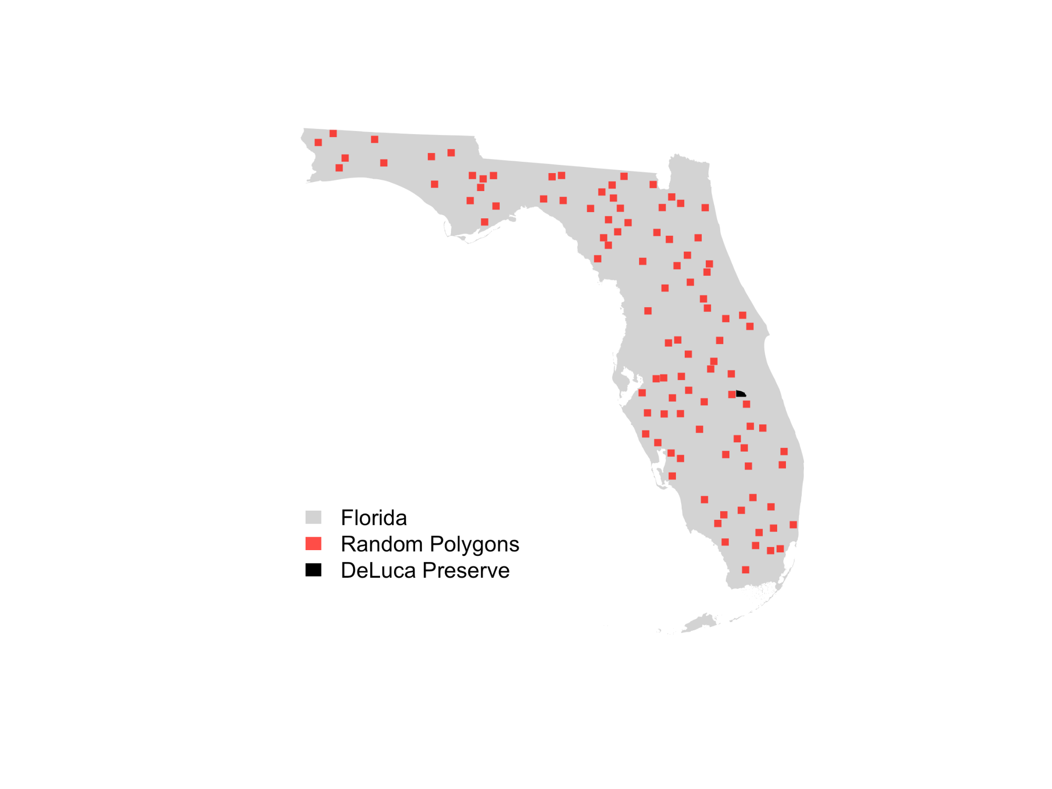
Figure S1. To determine the cumulative effort and illustrate the potential people-hours compared to other locations in Florida, we generated 100 random square boundaries with the same area as the DeLuca preserve across Florida.
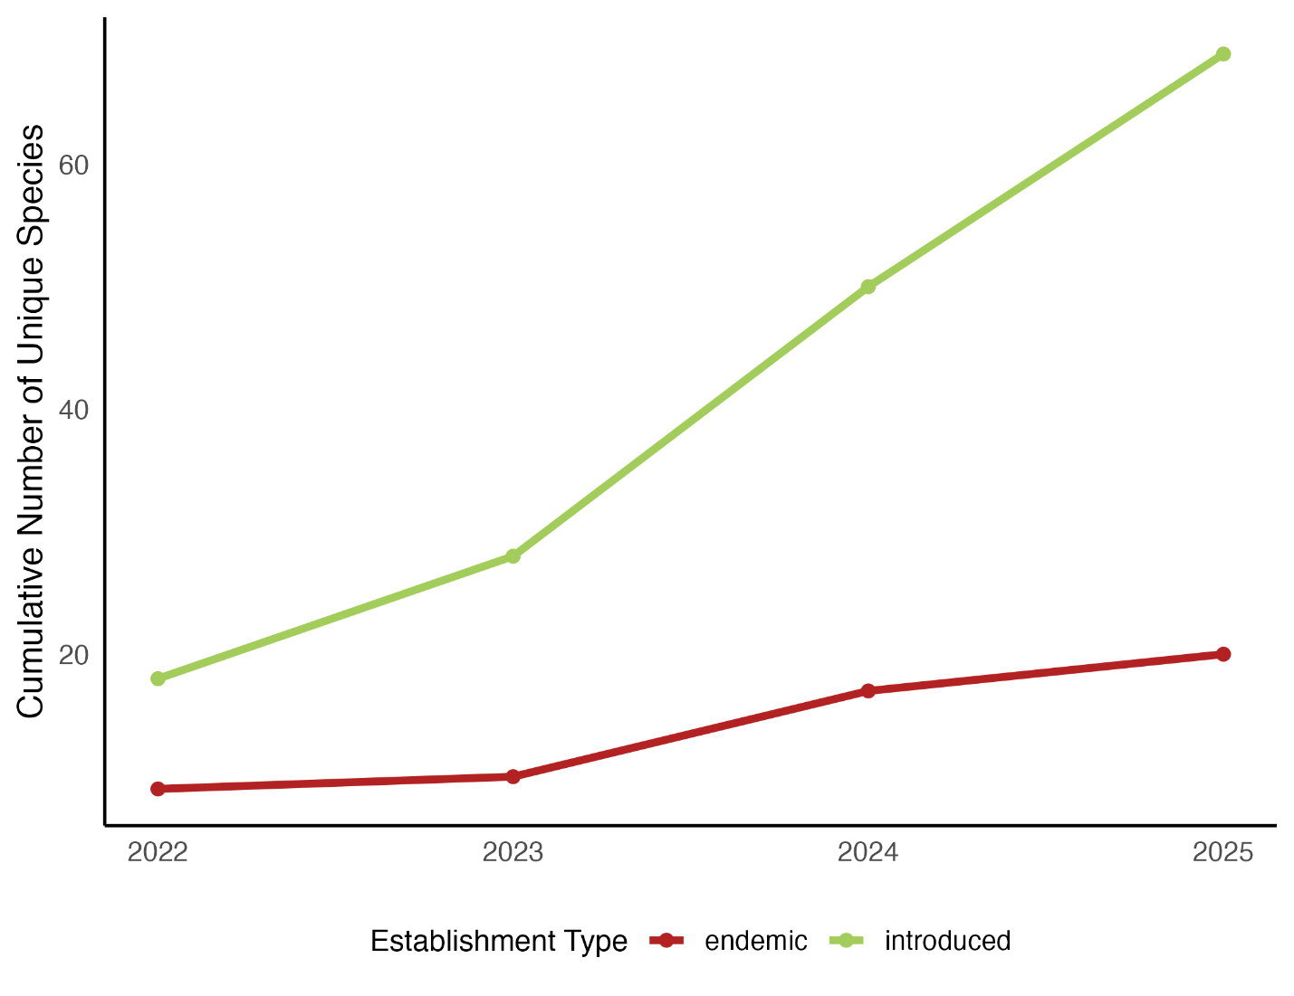
Figure S2. Cumulative number of endemic and introduced species recorded during bioblitz events at DeLuca Preserve, based on Research Grade iNaturalist observations. The orange line represents the number of introduced species over time. The blue line represents the number of endemic species to Florida over time. Both represent an increase in findings of establishment type per sampling effort.
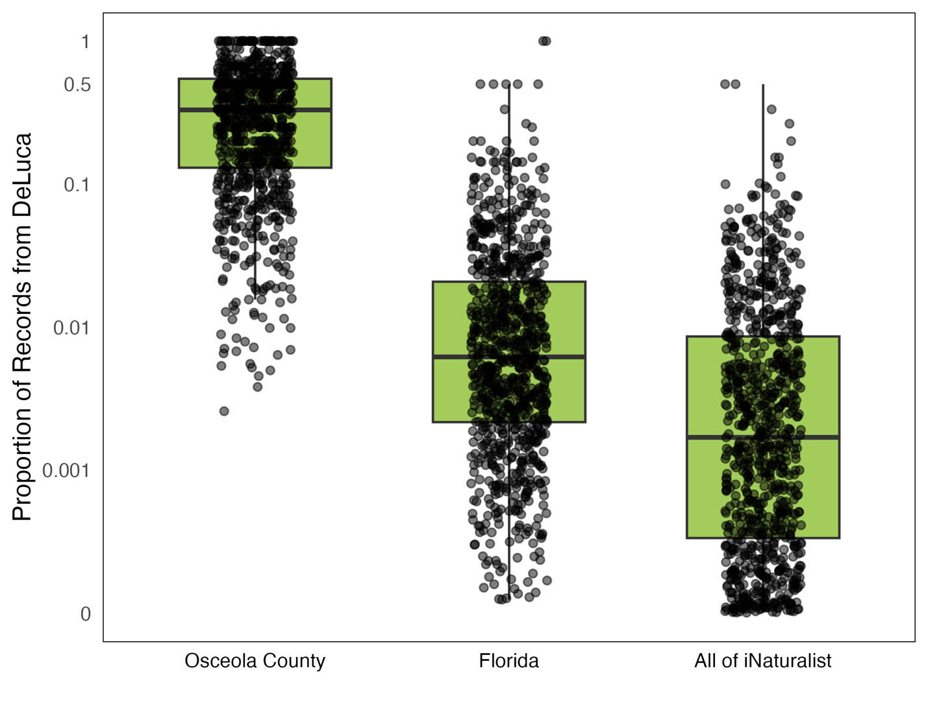
Figure S3. Proportion of all recorded observations per species that originated from the DeLuca Bioblitzes across different spatial scales. Each point represents a single species, with boxplots denoting the interquartile range. The three panels correspond to (from left to right): observations within Osceola County, all observations across Florida, and all observations on iNaturalist. All observations are Research Grade.
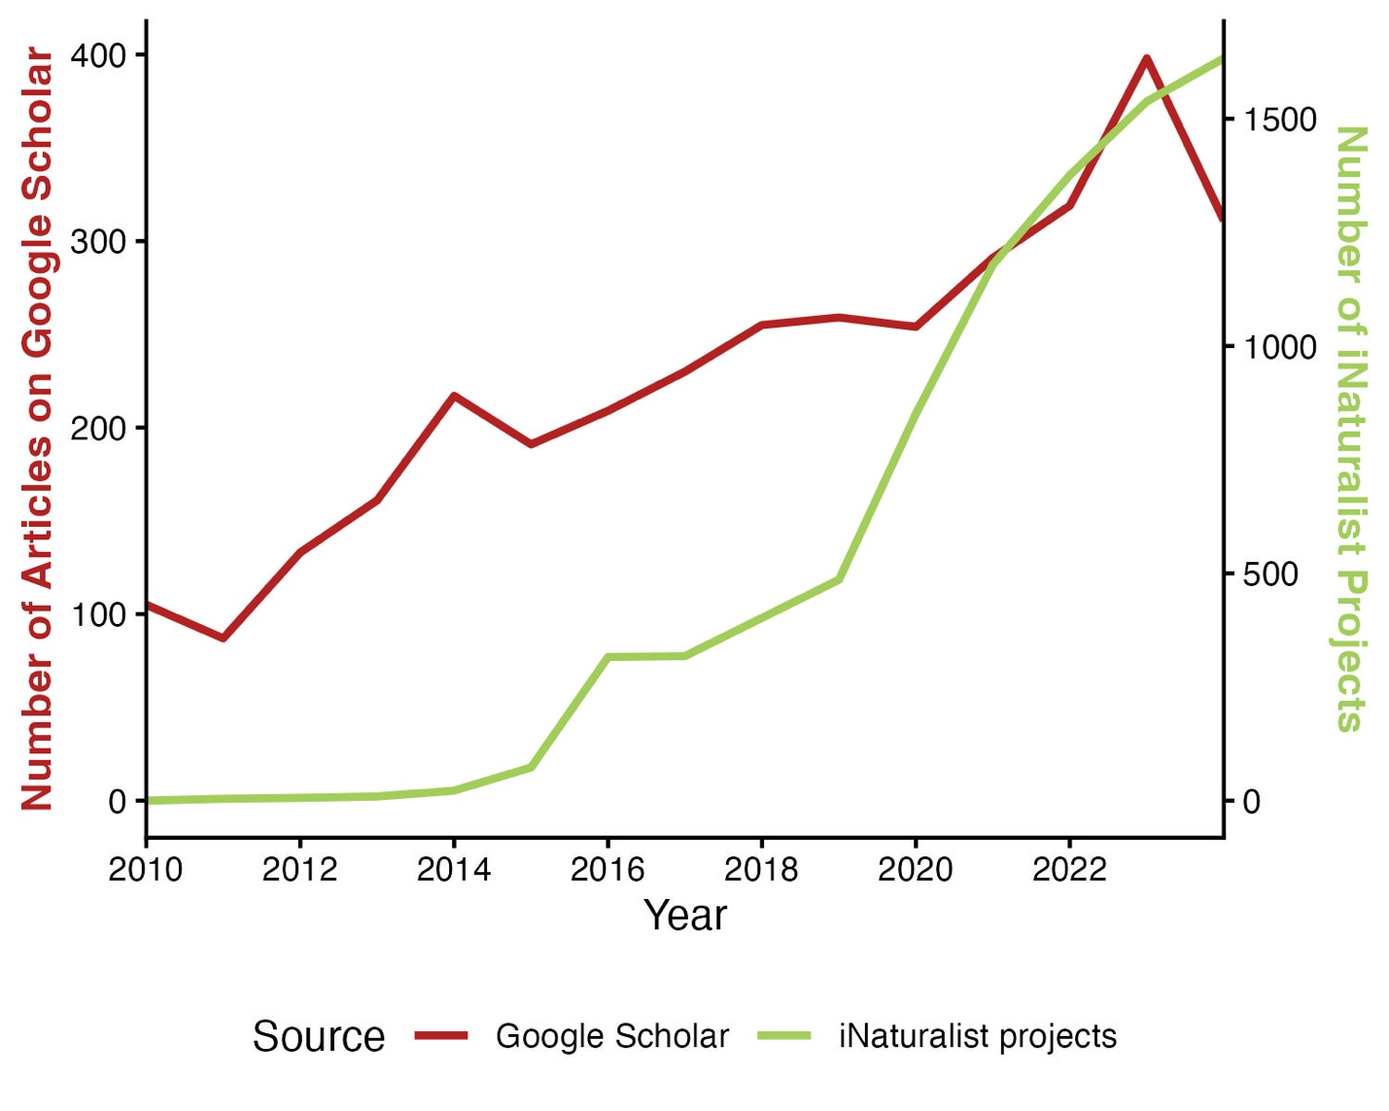
Figure S4. The blue line represents the number of articles returned from Google Scholar searches for the term “Bioblitz” by year. The orange line represents the number of iNaturalist projects that contain the term “Bioblitz” by year. Both cases illustrate the increasing popularity of bioblitzes over time.

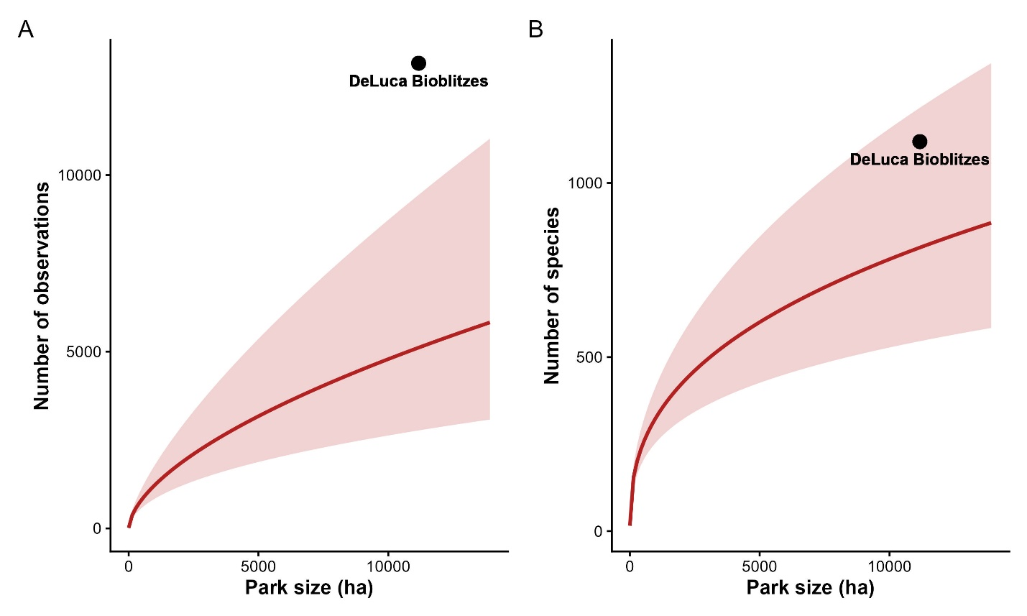
Figure S5. To explore how DeLuca Preserve Bioblitz observations compare to observations in Florida state parks, we modeled the relationship between number of observations and number of species across 39 state parks (see Lowe et al., 2026). We ran two negative binomial generalized linear models: one with the number of observations as the response and log-transformed park size (ha) as the predictor, and one with the number of species as the response and log-transformed park size (ha) as the predictor. Model structure was chosen based on residual diagnostics using the DHARMa package in R (Hartig, 2024). We then plotted the fitted trend lines with standard error, and highlighted data from the DeLuca Bioblitzes with a point showing where it falls on each graph. Note that the state park data covers all dates in iNaturalist, whereas DeLuca Preserve Bioblitz represents only observations taken during four bioblitzes. This plot illustrates the value of bioblitzes to collect more observations and species than passive observation.

